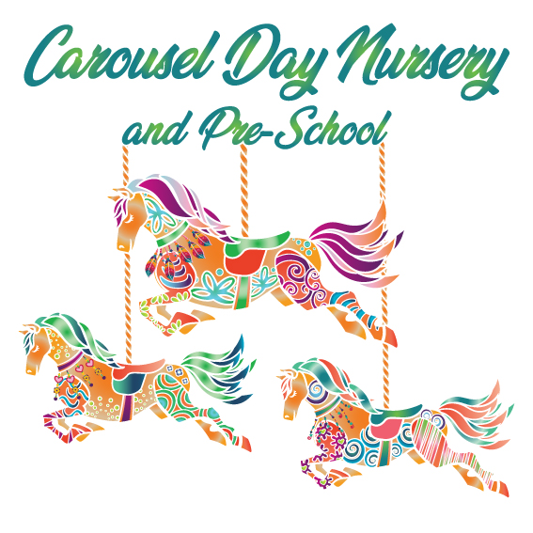

Health Protection Policy

To prevent spread of infection and maintain cleanliness of the premises and equipment:
- We adhere to the guidance of the local Environmental Health Department and the Health Protection Agency
- Nursery premises are cleaned at the end of each day by our cleaner, adhering to our Daily Cleaning Schedule
- Cleaning of toys, dressing up clothes, play equipment and all furnishings is carried out according to the individual room Cleaning Rotas
- All laundry is washed and dried by the staff, daily.
- Children have their own bedding which is stored on-site and washed weekly.
- Hand washing sinks are in the Kitchen, Staff Washroom and all children’s rooms.
- Children have their hands washed prior to every meal (including snack time) and afterwards.
- All children are supervised during toileting and step by step hand washing posters are on display above the sinks
- Each Play Room is equipped with Hand Sanitising Gel dispensers (staff only)
- Each Play Room is equipped with a lidded bin for the hygienic storage of waste
- Each Play Room is equipped with a sink, at the children’s level, for children to wash their hands throughout the day.
- Carousel has a written procedure for the hygienic changing of nappies
  - Protective clothing (disposable aprons / gloves) are worn during nappy changing and staff wash their hands between nappy changes.
  - Bins are provided for the hygienic storage of soiled nappies.
- Communicable play i.e. sand / water / food would be postponed during an outbreak of any communicable disease in nursery
- Nursery cooks and staff are trained and qualified in Food Hygiene procedures
- Kitchen is equipped with dishwasher for the hygienic cleaning of all crockery, utensils, cutlery etc
- The kitchen has a ‘Food Handling’ procedure that the cooks and all users of the kitchen adhere to.

Procedure for Sick Children
- Confirm with Management Team the child’s condition
- If the child needs hospital treatment, call an ambulance immediately
- If hospital treatment not necessary, but child considered to be infectious, then segregate child in ‘sick bay’ area (baby room separated)
- Contact parents / carers to organise collection as soon as possible
- Ensure toys that are played with in this area are sterilised once the child leaves nursery

If the child has a high temperature of 38c or above:-

- Call parents / carers to seek verbal permission to administer medicine to reduce temperature and arrange for collection of child.
- If permission given, administer infant paracetamol – dosage as directed on the bottle
- Any child presenting at nursery with a temperature must go home, even after Calpol administered.
- Record medicine dosage and ensure that written consent is sought from parents/carers on arrival at nursery
- If parents or emergency contacts cannot be reached, we may administer Calpol in the instance of a severely high temperature (39.5+) without permission.

Administering Medicine at Carousel
If a parent has administered Calpol/Nurofen to their child at home to treat illness or a high temperature, they must keep their child at home until their temperature has stabilised and they are well enough to be in nursery, without the need for medication.

Non-prescribed medicine – i.e. cough preparations / infant paracetamol
We will NOT administer non-prescribed medicines to the children in our care, except in the circumstances as described above in the Procedure for Children taken ill at Nursery. Verbal consent given by the child’s doctor, or parents/carers will not be acceptable.

‘Over the counter’ Teething Gels and Powders will be given to aid comfort for teething babies and consent will be sought through use of the Medical Consent Form

Prescribed medicine – i.e. anti-biotics / inhalers / epi pens
- We will administer prescribed medicines to children within our care, provided they are well enough to attend nursery, engage in nursery activities and not require one-to-one care. Prescribed medicine must be clearly labelled with the child’s name and pharmacy / doctor’s instructions on dosage. Parents must complete the Medical Consent Form ensuring that we have the information required. All medicines will be stored in the Baby Fridge.
- Self-held medication i.e. inhalers will be given to the children as instructed by parents and a Medical Consent Form completed.
- Epi Pens will be administered to those children with specific allergy conditions but only with a full protocol signed by parents. Epi pens must be brought into nursery each time the child attends and taken home at the end of each session. Staff must check that the Epi Pen arrives with the child, if not the parent/carer must return home to collect the Epi Pen before the child is left within our care.
- Parents are responsible for informing nursery staff of any changes to the medical conditions/details of their child, i.e. updated immunisations, new prescribed medicine
- RabbiNappy Cream - a named tub should be supplied by parents to ensure it meets the child’s individual needs and so we can avoid allergic reaction to some products.
- Baby Wipes are supplied by Carousel. Parents should notify us if our products do not meet the needs and preferences of their child.
- Staff medication will be stored in the kitchen fridge and is the responsibility of the staff member concerned.

First Aid
- A majority of the staff team are qualified in Level 3 paediatric first aid.
- This is updated every three years, using an in-house training programme delivered by an approved first aid trainer.
- First Aid Boxes are located in the Staff Toilet, Rabbit Room, by the front door for walks (on a hook out of reach), and in the nursery garden storage cupboard. These boxes are regularly checked for supplies by Luiza Gibbon, our First Aid co-ordinator.
- Splinters: If a splinter is visible and it appears possible to remove, a trained first aider will use disposable tweezers to remove the splinter. They will then clean the area with soap and water, and apply a plaster. Staff will not ‘dig’ to remove an embedded splinter, and in that scenario will clean the area, apply a plaster and notify a parent if necessary.

Accidents & Incidents in Nursery / Out of Nursery Accidents
- We hold records of the above on the premises to record details of any existing injuries that a child may have when arriving at nursery and both accidents and incidents that occur in nursery.
- Details will be recorded by the nursery staff, signed and witnessed by them and the parents.
- In the event of a more serious injury to a child we will call an ambulance where necessary. We will inform Ofsted, HSE and the local child protection agency, if appropriate.

Reporting of ‘notifiable diseases’
- If a child or adult is diagnosed as suffering from a notifiable disease under the Health Protection (Notification) Regulations 2010, the GP will report this to Public Health England.
- When we become aware, or are formally informed of the notifiable disease, the manager informs Ofsted and contacts Public Health England, and acts on any advice given.

Nits and head lice
- Nits and head lice are not an excludable condition, although children need to be having treatment before returning to nursery and in exceptional cases a parent may be asked to keep the child away until the infestation has cleared.
- On identifying cases of head lice, all parents are informed and asked to treat their child and all the family if they are found to have head lice.
Further guidance
- Good Practice in Early Years Infection Control (2009)
- Medication Administration Record (2013)

Promoting Health and Hygiene
INFANT CALPOL ADMINISTERING POLICY
Policy statement

While it is not our policy to care for sick children, who should be at home until they are well enough to return to nursery, we will administer Calpol as part of maintaining their health and wellbeing and to relieve the symptoms of pain or a fever. We only administer Calpol after having sought the permission of parents and when collection of the child has been arranged. We do not administer Nurofen.

A child who has been given Calpol or Nurofen before coming into nursery will not be admitted because:
- This can mask the symptoms of illness and when the medicine wears off the child may be too unwell to be at nursery.
- This can mask the symptoms of infectious illness, which places other children and staff at risk.
- This prevents us from being able to give further paracetamol to bring down a fever, which can be dangerous.

Parents must keep their child at home until their temperature is stable and/or they are well enough to be in nursery without the need for medication.

Procedures
- Once staff have agreed that the child would benefit from fever / pain relief, verbal permission from parents for the administration of Calpol will be sought.
- Parents will be informed that they need to arrange collection of their child as soon as possible
- Dosage will be administered in line with instructions on the bottle / packaging
- A Medicine Form will be completed (the emergency section) and parent signature required at child collection.

