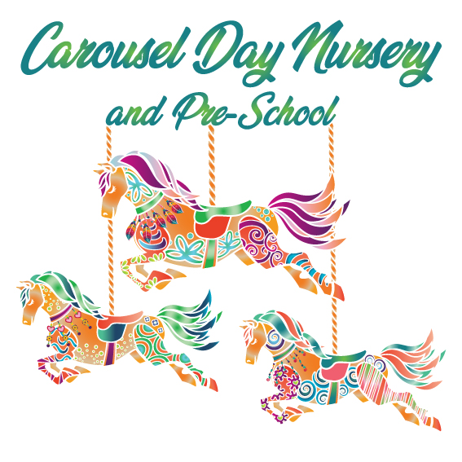

Policy area: Health & Hygiene
Toilet Training

Children become ready to toilet train at different stages of their development, although most children will be toilet trained before they start in our pre-school. We will work with parents to help a child to toilet train and adopt a consistent approach as far as is practicable.

Some children won’t show any signs of being ready to toilet train and for those children a judgement must be taken by parents/practitioners as to whether the child is developmentally ready to begin training. However, some signs that a child is ready include:

- They show an awareness that they have wet and soiled their nappy (e.g. pulling at nappy, fidgeting, trying to remove nappy).
- They show an awareness of the sensation of needing the toilet (e.g. holding themselves, fidgeting, hiding)
- They may communicate using speech that they have a wet or soiled nappy.
- They show enthusiasm to sit on the toilet, possible copying friends or family.

Procedure for toilet training at Carousel Day Nursery & Pre-school

- At nursery we have child sized toilets, which the children generally feel very comfortable with using because they are smaller than a normal toilet. It is much more hygienic for us to use toilets instead of a potty, so this will always be what we encourage the children to use. However, if a child is only comfortable with using a potty we do have one they can use. We will only get the potty out when the child needs the toilet, it will then be cleaned after use and put in our bathroom cupboard.
- The child’s Key Worker will discuss with parents the routine being used at home and we will work as closely as possible to keep to that routine at nursery. However, we have to consider the hygiene standards of the nursery and pressure placed on our staff team, so we may not be able to mirror exactly what the child is doing at home.
- Good communication between nursery and home is vital for successful toilet training. We need parents to tell us before they intend to start toilet training so that we can prepare at nursery too. It is also vital that good communication continues throughout the process so all parties are aware of any problems, successes and changes to routine (e.g. no longer wearing nappy at nap time).
- We do not advise that children start toilet training at any time when there is major change or upheaval happening in their lives, as this can make the process much harder and success less likely. Such events could include moving rooms at nursery, moving house, the arrival of a sibling, separating parents etc.
- We ask that parents provide plenty of changes of clothes (a minimum of 5 please, 1 or 2 changes is not enough).
- We ask that the child is clothed for easy access i.e. no dungarees or belts, preferably no buttons on trousers either
- Training children will be asked at regular intervals if they need to use the toilet and the frequency of this will depend on the individual child and the frequency of accidents. Our practitioners will also look out for signs that a child needs the toilet and encourage them to go if necessary.
- Initially a child will be taken to the toilet by a practitioner to be instructed on the procedure (pulling down clothes, wiping, washing hands etc). Once they are capable of managing by themselves they will be encouraged to go independently.
- We will provide a ‘bathroom fun bag’, which will contain toys and books to help children who may feel anxious about using the toilet or who wish to get off the toilet too quickly. These items will distract them or improve their mood whilst using the toilet.
- We will encourage children to learn about toilet training through their play, providing resources and planning activities that will support their development in this area.
- Boys must sit down when going to the toilet. Children empty their bladder fully when they are sitting as opposed to standing. It is also our experience that nursery-aged children are unable to reach/aim/hold themselves, so standing up to wee is impractical.
- If a child suffers from severe constipation this will have an impact on their ability to toilet train. Therefore they must have their constipation under control before they can start toilet training at nursery (symptoms being treated and alleviated).
- We will use a personalised sticker chart for children who are toilet training to motivate and encourage them. We will give a copy of the chart we use to parents so they can use it at home too.
- If a child has had an accident and has used all their spare clothes from home, then they will be put into either nappies or pull-ups, to maintain hygiene standards within the nursery. As such, please ensure that when your child is toilet training they have a few nappies in their bag.
- If a child has an accident, we will write this down to inform parents. We will never use negative language or attitude when a child has a wee/poo accident. This will be dealt with professionally and with minimal fuss in order to ensure the child is not upset.
- Most children who start toilet training will still need to use a nappy at nap time. If this is the case for your child, please ensure we have a sufficient supply of nappies for them. Once a child is consistently dry at nap time we will stop using the nappies and let parents know they are no longer required.
- If it is our professional opinion that a child is not yet ready to toilet train (possibly owing to their attitude to the toilet or the number of accidents they have when at nursery) we will inform parents that we cannot yet support toilet training. As a group setting we must consider the wellbeing of all the children in our care and the pressures placed on our staff team.

